Seneca Polytechnic
2D Collision Detection
GAM531
Yuhan Zhao
11-12-2025

Introduction
An engaging game often contains realistic physics simulation, like gravity and force, this type of game mechanic can create an immersive game experience for the player.
In Physics engine, collision detection is a process of detecting if two or more objects in a scene comes into contact. It is a fundamental part of physics, and it allow game developers create animation response like bouncing, or make characters take damage.

Challenges
There’s a lot of meshes in a game, some of them might have irregular shape or rotation. It becomes very difficult for us to check whether two complex shapes overlap each other, such operation will be very computationally intensive if we want to check if all vertices and triangles are not touching.
To keep games run efficiently, game developers need a more simple way to check for collisions, and AABB (Axis-Aligned Bounding Box) helps developers achieve that.

AABB (Axis-Aligned Bounding Box)
An AABB is a rectangle box that always aligns with the XYZ axis. It determines the collision boarder of objects, no matter the shape and rotation.
The benefit of AABB is its efficiency in detecting overlap of bounding boxes, but the detection is not always precise, like the 2 shapes below.
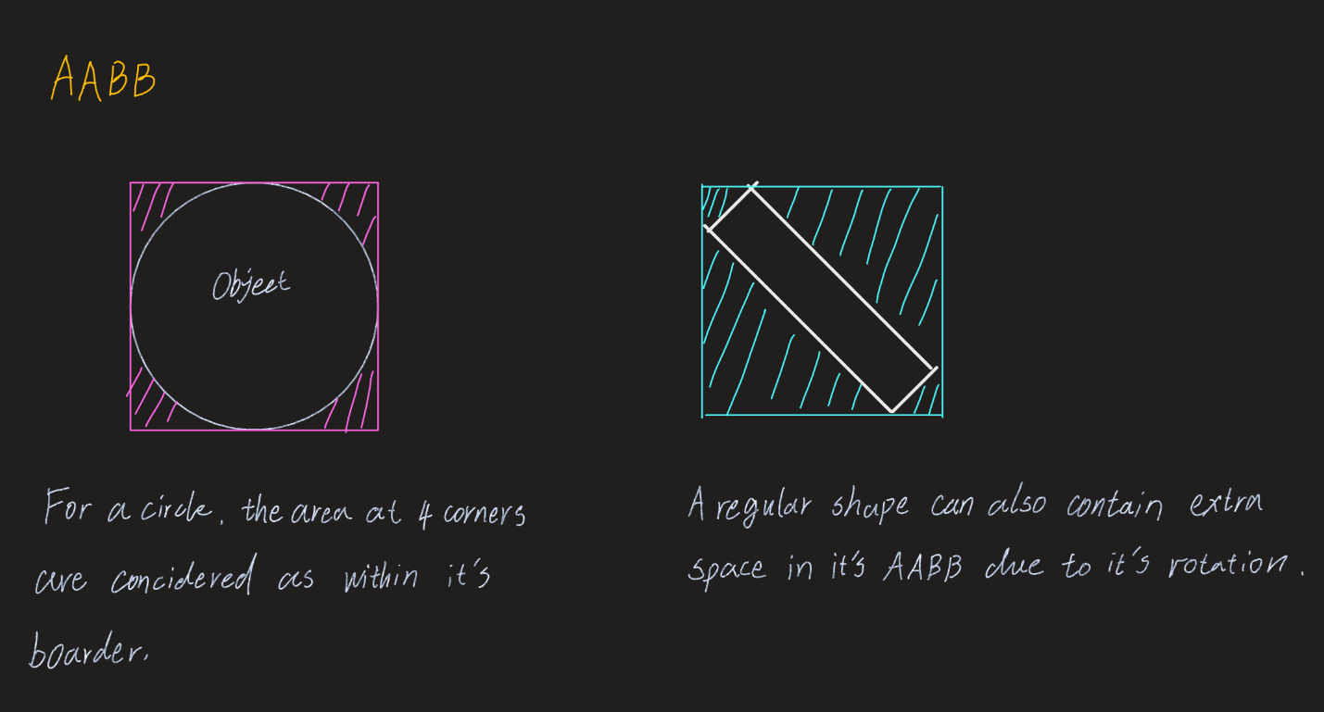
For 2 AABB to overlap, they must overlap on both x and y axes.
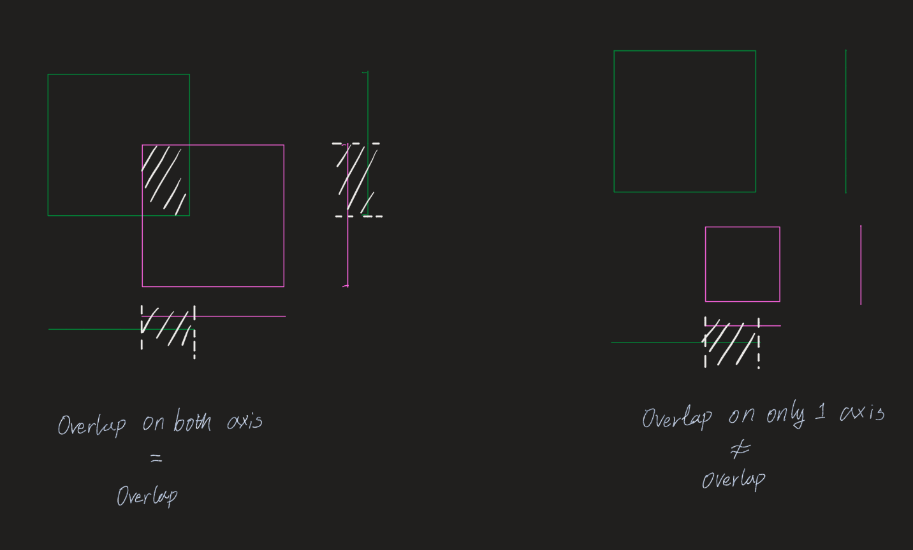

AABB – Circle
For a circle and AABB, we need to find the closest point on the AABB to the center of the circle. Then we can find the distance between that point and the center of the circle and compare it with the radius of the circle, if the distance is shorter than radius, there’s a collision. The following diagram shows an example of how to find the point D on AABB that is closest to the circle.
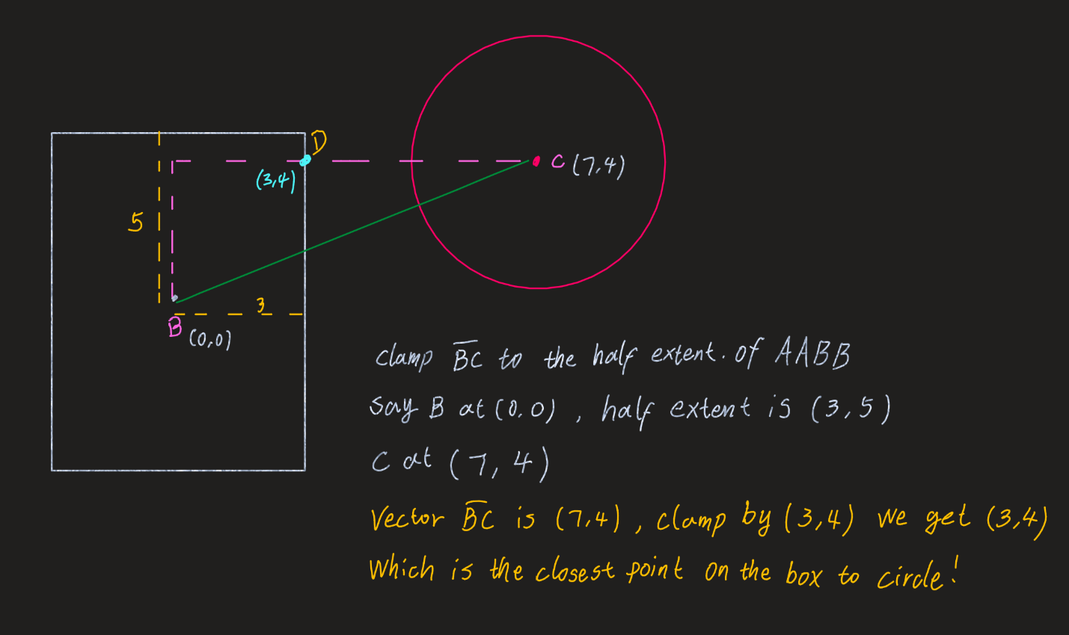

The Clamp Function
Clamp(value, min, max) helps us keep a value in the given range,
- If value < min, return min
- If value > max, return max
- Otherwise return value
It is important when finding a projection of a point to a box. Let’s look at the previous example, in order to find the projection of point C on to the box, we need to
- First find the vector BC which is (7, 4)
- Then clamp the vector to the half extent of the box which is (3, 5)
- Since 7 > 3, 3 is returned,
- Since 4 < 5, 4 is returned
- (3, 4) is the point we are looking for

